Equitable Access Action Planning Toolkit
(Please make and save a copy of this template for your own use by clicking “File” then “Make a Copy”.)

NOTABLE SCHOOL DATA:
School Demographics (race, ethnicity, age, grade, etc)
Percentage Title 1:
Chronic Absenteeism Rate:
Students in Temporary Housing Rate:
Languages Spoken:

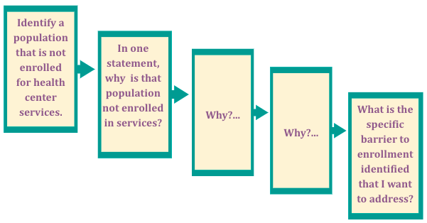
STEP 1: Identifying Barriers to Enrollment
Understanding barriers to enrollment will help you in planning targeted enrollment strategies to mitigate barriers you have identified. First, identify which students are enrolled and not enrolled for the health service. Then, complete the following WHY Protocol to identify barriers to enrollment for specific students and families. This exercise will also help you identify individuals and groups of students/families who may experience the same barrier to enrollment.
Identify a population that is not enrolled for health services: | In one statement, why is that population not enrolled in services? | Why? | Why? | What is the specific barrier to enrollment identified that I want to address?
Ex: Students who have recently arrived to the US | Ex. Some of their parents do not know about services and some are skeptical. | Ex. Information about services is not fully accessible to these families. | Ex.These students were not present during the school wide enrollment form distributions.  Enrollment forms are long and contain jargon that many people do not read or understand.  Parents are not familiar with the US Health Care System and are unsure of what SBHC services are, building distrust. | Ex.These students often enter school in the middle of the school year and may be absent often.  Health literacy level of SBHC enrollment forms is too high.  Adequate information about services is not provided to families so they don’t feel comfortable enrolling.
1.
2.
3.

STEP 2: Leveraging Stakeholder Relationships
Complete the Stakeholder Analysis Grid below to identify the people who can support your enrollment effort for populations with barriers to access! This includes all stakeholders who have relationships or communication with students, families and staff. Do your best to list all stakeholders you can think of in one category to best guide your enrollment strategy.
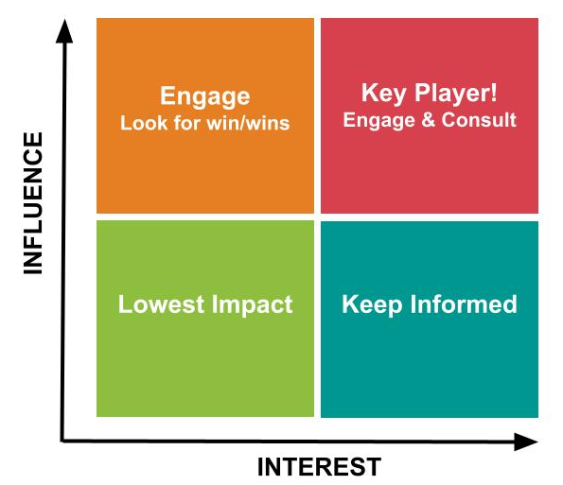
Who should you work to engage?  Who are the people with high influence but need to be engaged to increase their knowledge and interest in health services? These people may have strong connections with students and families but have never observed your health services, are newer in the building, or maybe haven’t met any of the health service providers on your team. Write them here!  - Ex: new teachers in the school, school social worker who works with many students who aren’t enrolled but hasn’t observed services | Who are your key players?  Who are the people who have high interest in your services and high influence with students and families you are targeting to enroll? These people will be champions of health services and have strong connections with students and families you are targeting to enroll. Write them here!  - Ex: school principal, PTA president whose child is enrolled in health services, ESL teacher who works closely with immigrant families, your clinic staff member who is also a parent at this school
Who is lower impact at this time?  Who has low interest in your health services and also doesn’t have high influence with targeted students and families at this time? These people should not be forgotten, but should not be the top priority for engagement for now. This list should be monitored over time as people’s interest or influence may change! Write them here. | Who should you keep informed?  Who are the people who have high interest in your services but lower influence with your target group for enrollment? These people may also be highly interested but don’t have as many connections to students or families. Write them here!  - Ex: school custodian who also cleans the clinic space and knows all the health service staff and the school staff

Step 3: Developing a Strategic Enrollment Plan
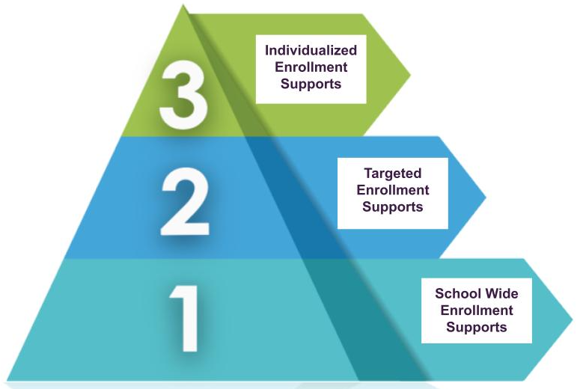
Now let’s make a plan! Complete the three tiers framework below to map out enrollment strategies for your health services that ensure you provide the right supports for all students and families.
*Template adapted from Attendance Works Three Tiers Framework to Improve Attendance

Tier 1: School Wide Enrollment Supports
This tier is the foundation of your enrollment plan and includes strategies you implement with all school staff, students, and families in the school to encourage enrollment in health services.
Tier 1 Enrollment Strategy | Supportive Stakeholders
Ex: Include enrollment forms with informative and easy to read cover page in the Welcome Back packet sent home by the school on the first day | Ex: Principal and school secretary who create Welcome Back packets
1.
2.
3.

Tier 2: Targeted Enrollment Supports
This tier is for students and families who need more encouragement and support to enroll in health services. The enrollment activities should target groups of students who share the same barrier to access or a need for a specific support in order to enroll. It is important to leverage identified stakeholders who have connections and influence with these groups of students to support your strategies.
Targeted Group | Tier 2 Enrollment Strategy | Supportive Stakeholders
Ex: Spanish speaking students and families | Ex: All enrollment forms, informational flyers, signage for health services translated into Spanish | Ex: PTA president who is a Spanish speaker and whose child is enrolled in services
1.
2.

Tier 3: Individualized Enrollment Supports
This tier is for students and families who face significant barriers to enrollment and require individualized strategies of outreach and support. Keep in mind that students in this tier may take time to overcome barriers or to build trust required for enrollment. It is critical to leverage identified stakeholders who have trusted relationships with students and families in this tier.
Targeted Individual | Tier 3 Enrollment Strategy | Supportive Stakeholders
Ex: Recent immigrant family with distrust of health services due to paperwork that may be required | Ex: Outreach in person by a health service staff person and the student’s teacher | Ex: the student’s teacher who is the primary trusted contact at the school
1.
2.
3.

